Machine Description | Death Note is a boot2root VM where initial access is gained via a vulnerable web service and misconfigured credentials, leading to remote command execution and staged local privilege escalation to root.
Target IP | 10.255.112.115
Vulnerability Name | Vulnerable web service and misconfigured credentials
Service / Version | TCP / 80 HTTP Apache httpd 2.4.38
CVSS Score / Severity | 9.8 Critical
Attack Vetor | CVSS:3.0/AV:N/AC:L/PR:N/UI:N/S:U/C:H/I:H/A:H
Proof Of Concept | STEP 1 – Discover the Target IP using Netdiscover  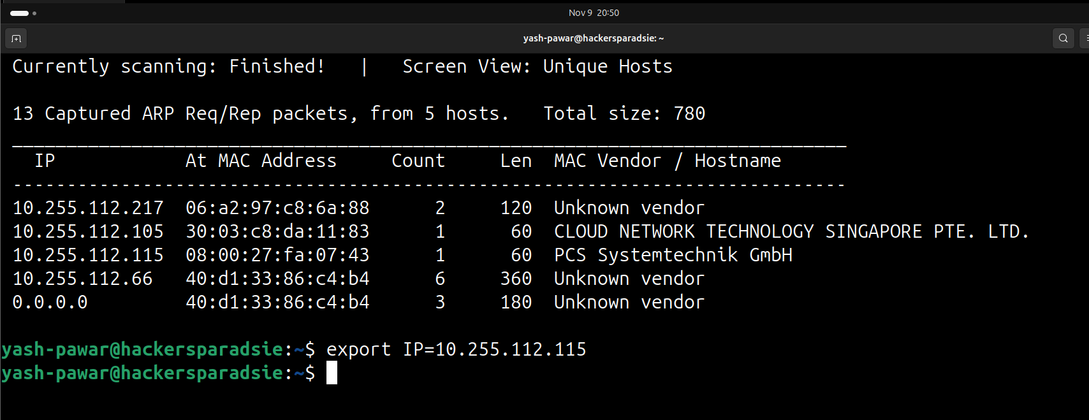  STEP 2 – Adding hostname to /etc/hosts file  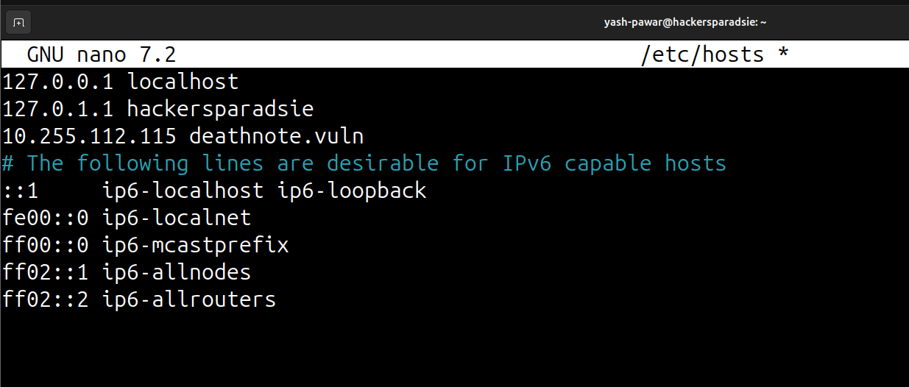  - Now browser is able to resolve IP from local host’s file  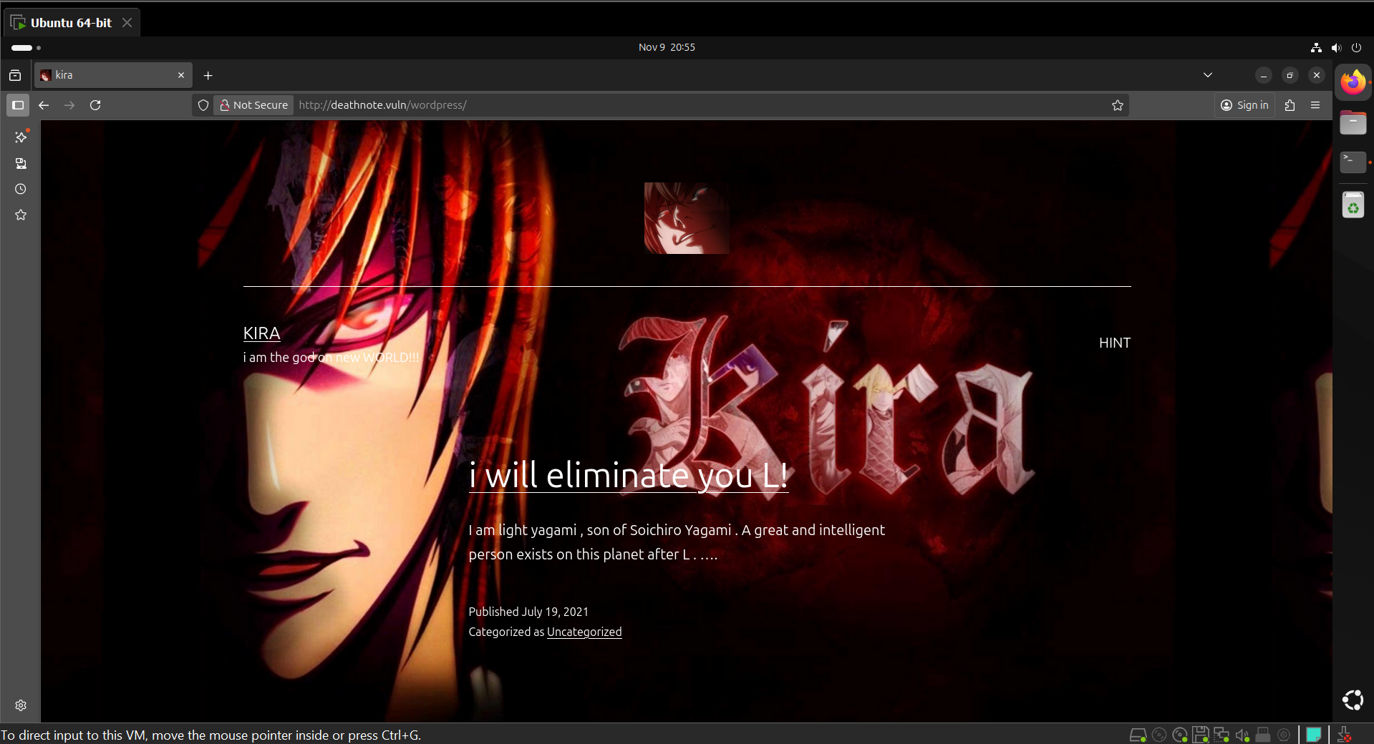  STEP 3 – Scan the target for open ports and services  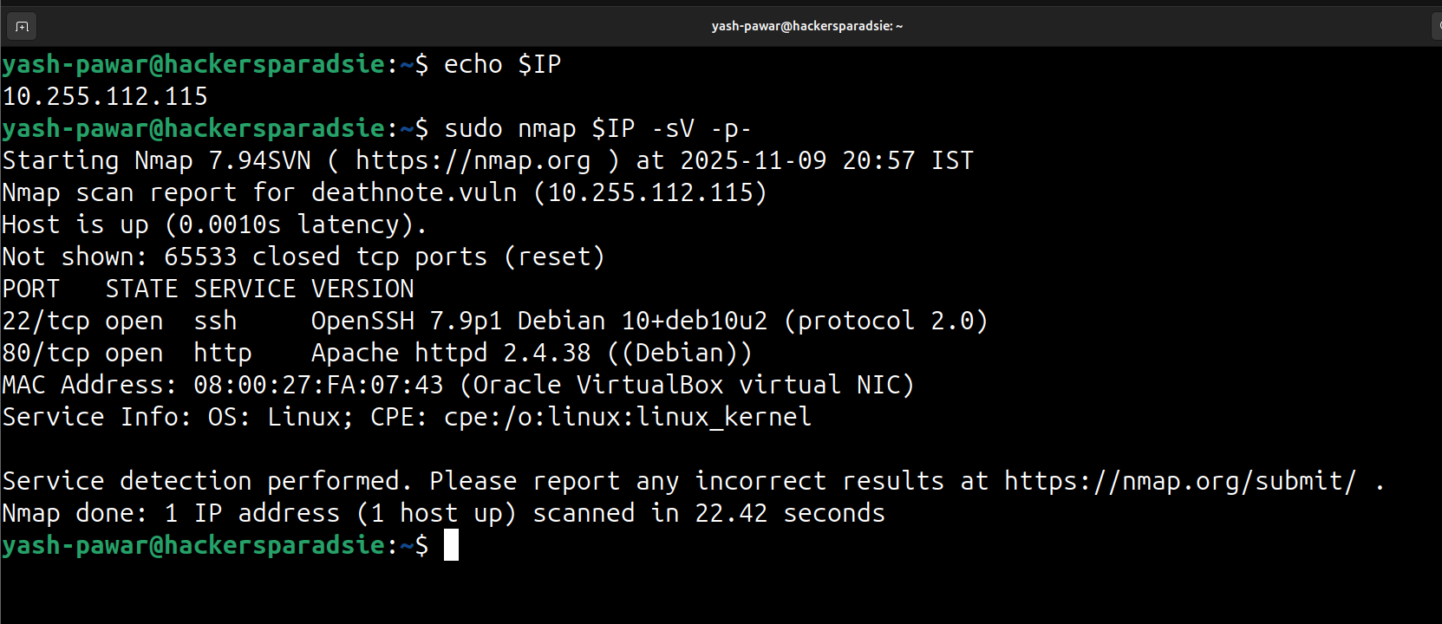  STEP 4 – Enumerating port 80 for available directories and files  - Directories  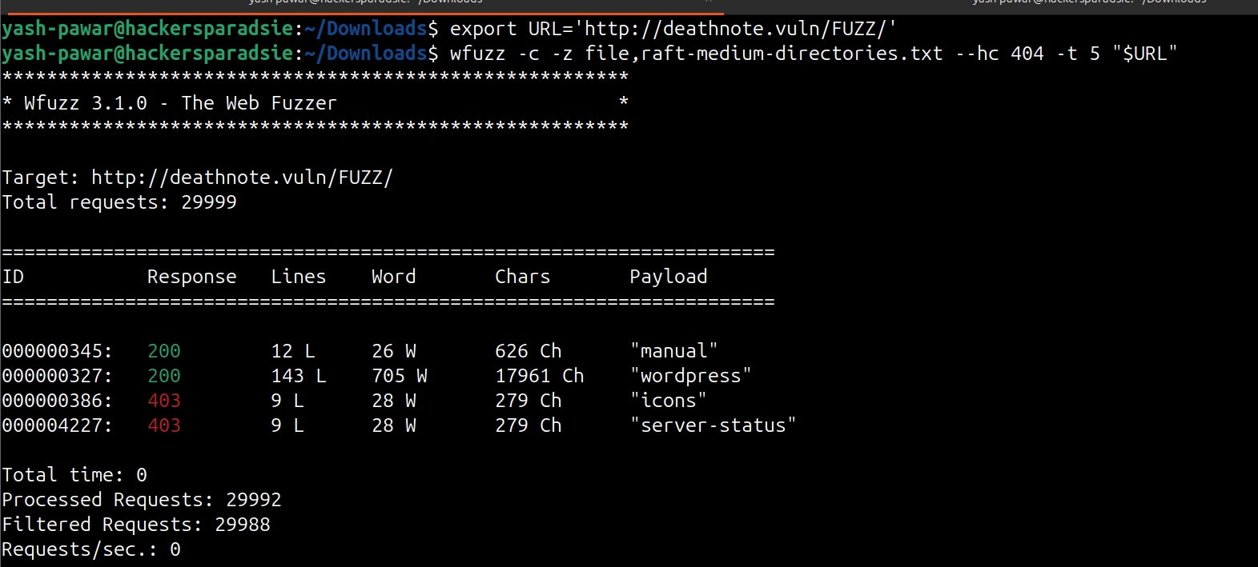  - Files  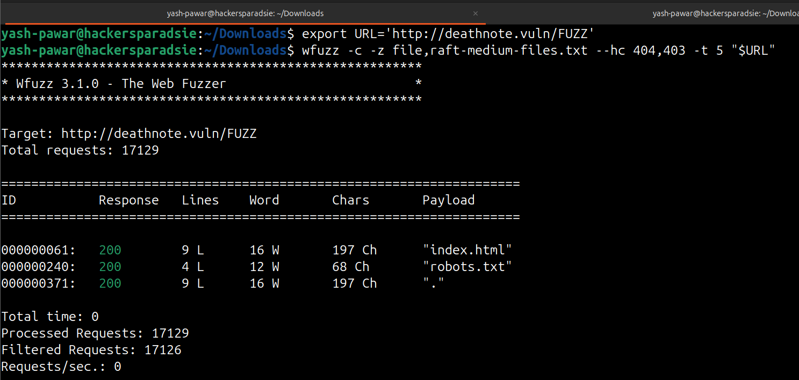  - Data got from robots.txt  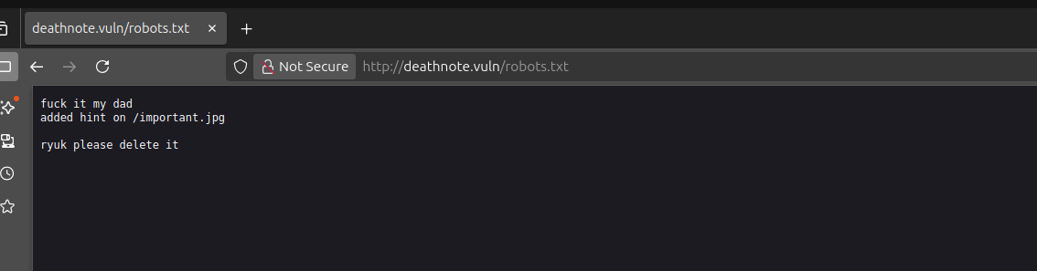  - Lets try to access  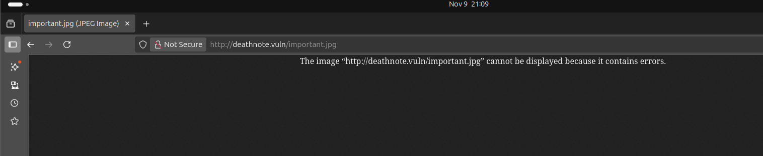  - It says some kind of error lets try curl  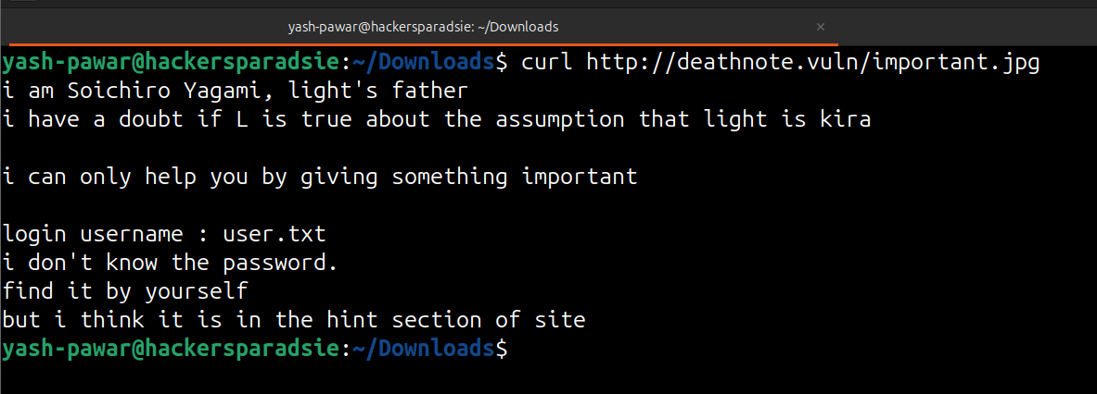  - We got valid user info here its user.txt but we need to find user.txt and passwords on website lets use dib for recursive fuzzing  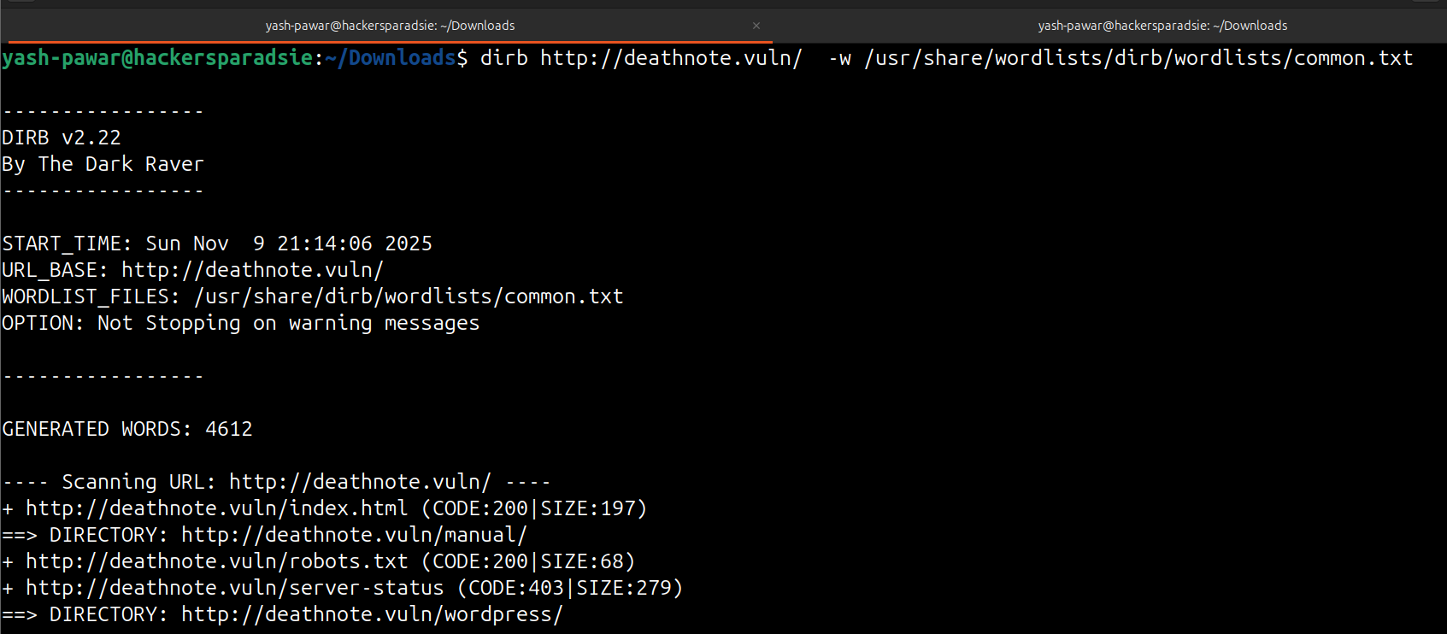  - FOUND ( http://deathnote.vuln/wordpress/wp-content/uploads/ )  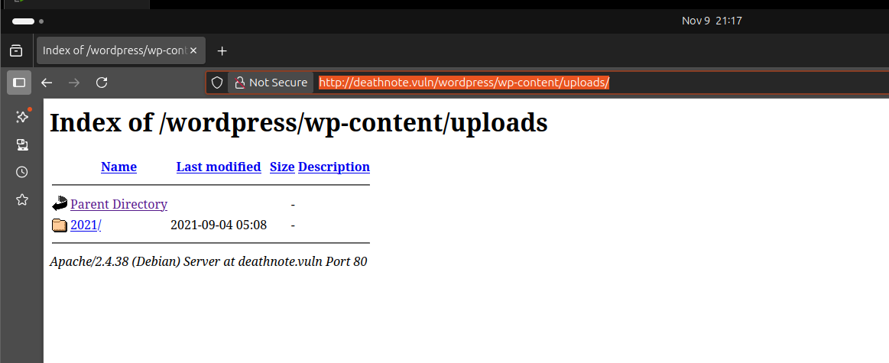  STEP 5 – Fetch the files using wget for the target  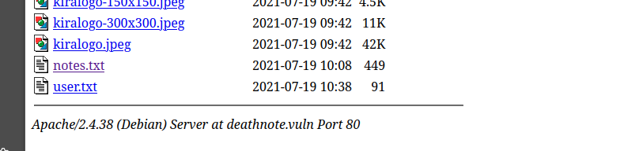  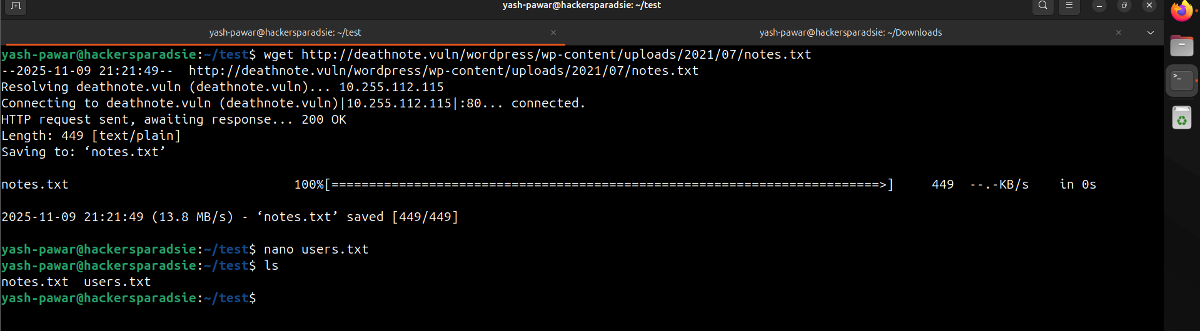  We do have some users and passwords combo lists  STEP 6 – Brute Force SSH for valid session on target device  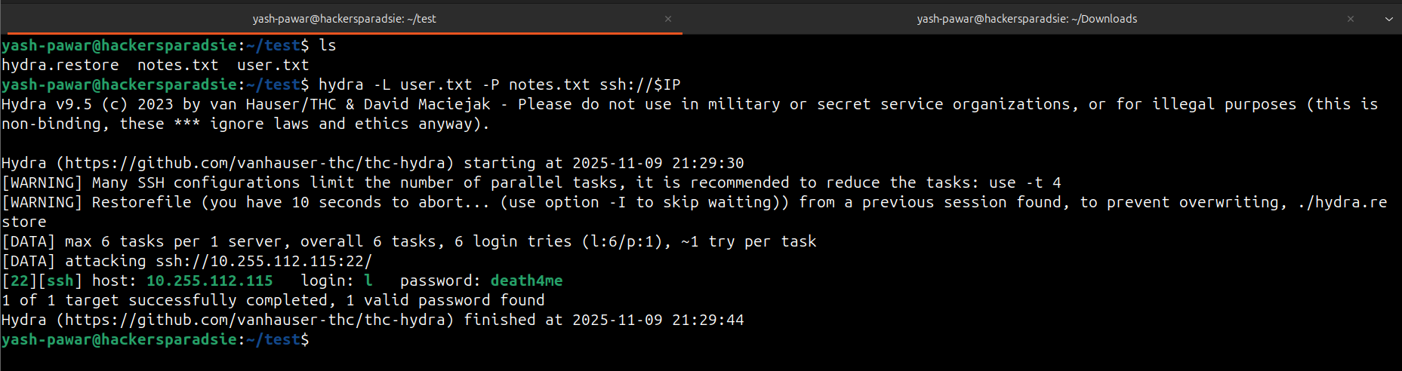  - Got Valid Creds User ( l ) Password ( death4me )  STEP 7 – Login using SSH  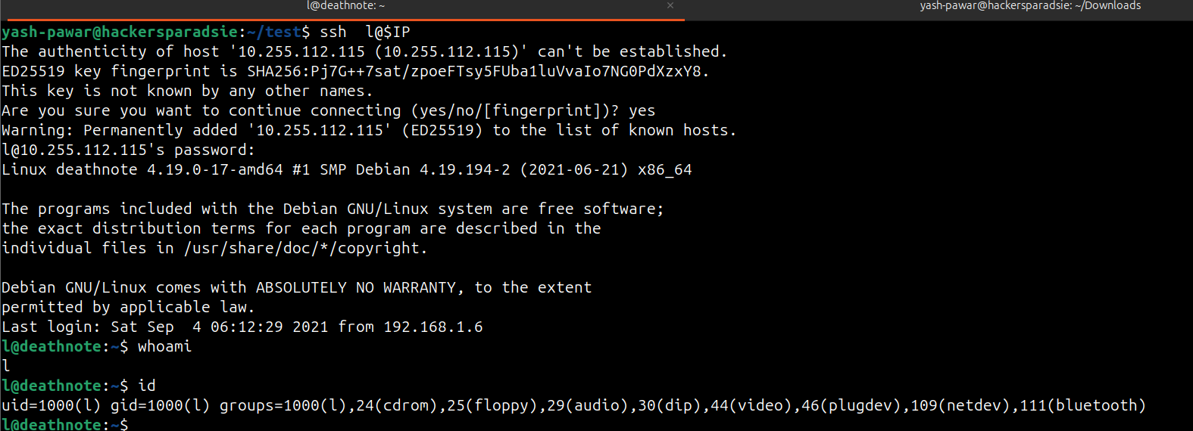  STEP 8 – Got access as normal user lets try to Escalate. Found the users.txt and have some value  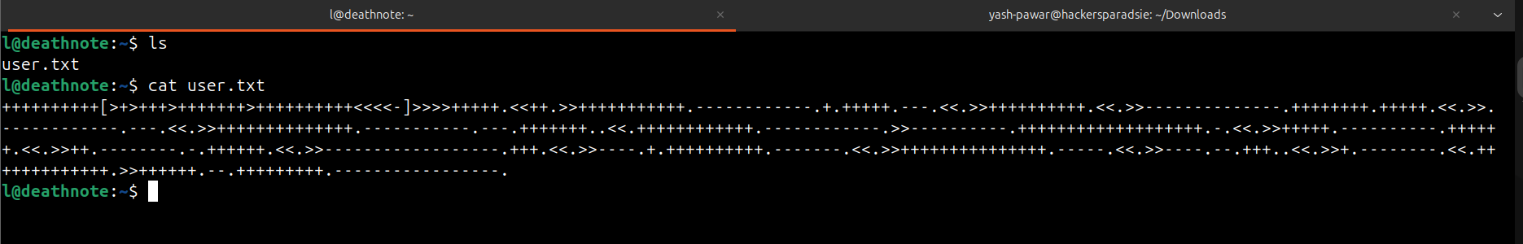  - It’s encoded in brainfuck lets decode it Online and here we got one hint  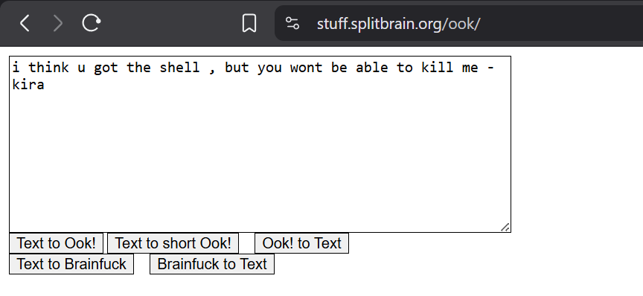  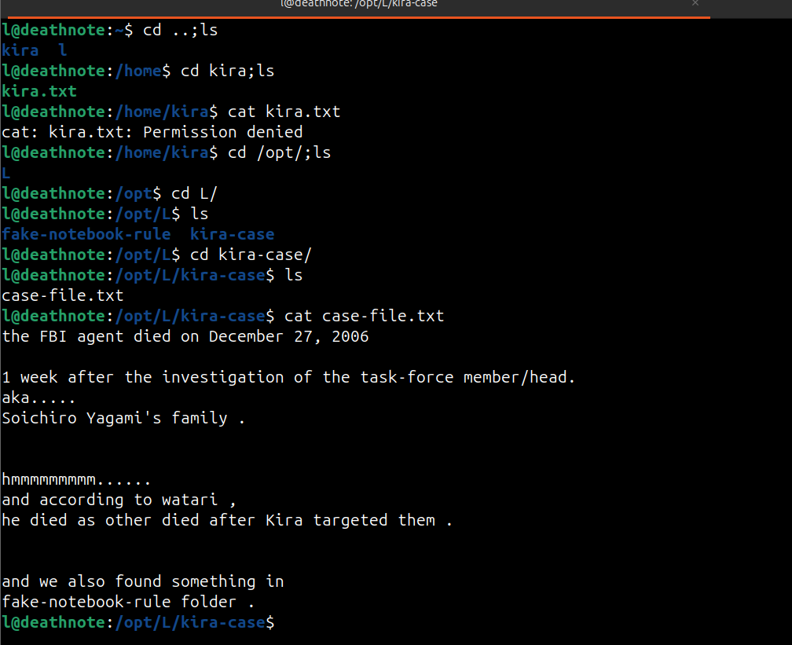  - Kira is the other user on the vulnerable machine.  We are investigating files related to the Kira case under /opt/L/, uncovering clues in case-file.txt that reference Soichiro Yagami’s death and a folder named fake-notebook-rule.  - We can see a file called Kira, whose permission to access the account l is denied. We need to access Kira’s account.  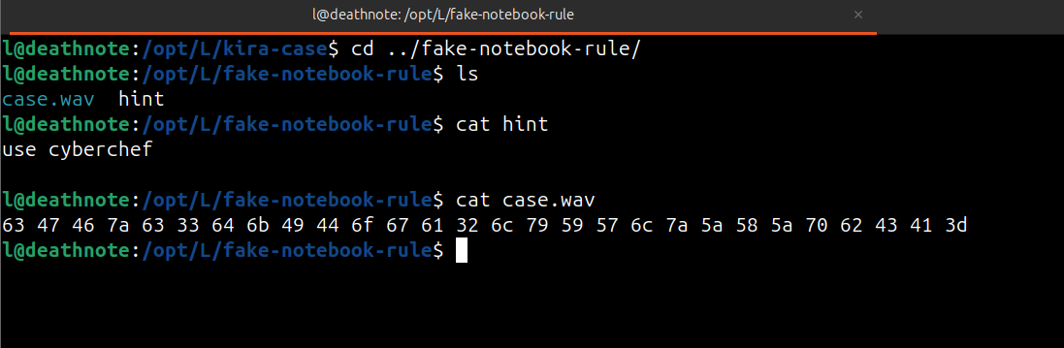  We got some encoded text here. Let’s try to decode it on cyber chef  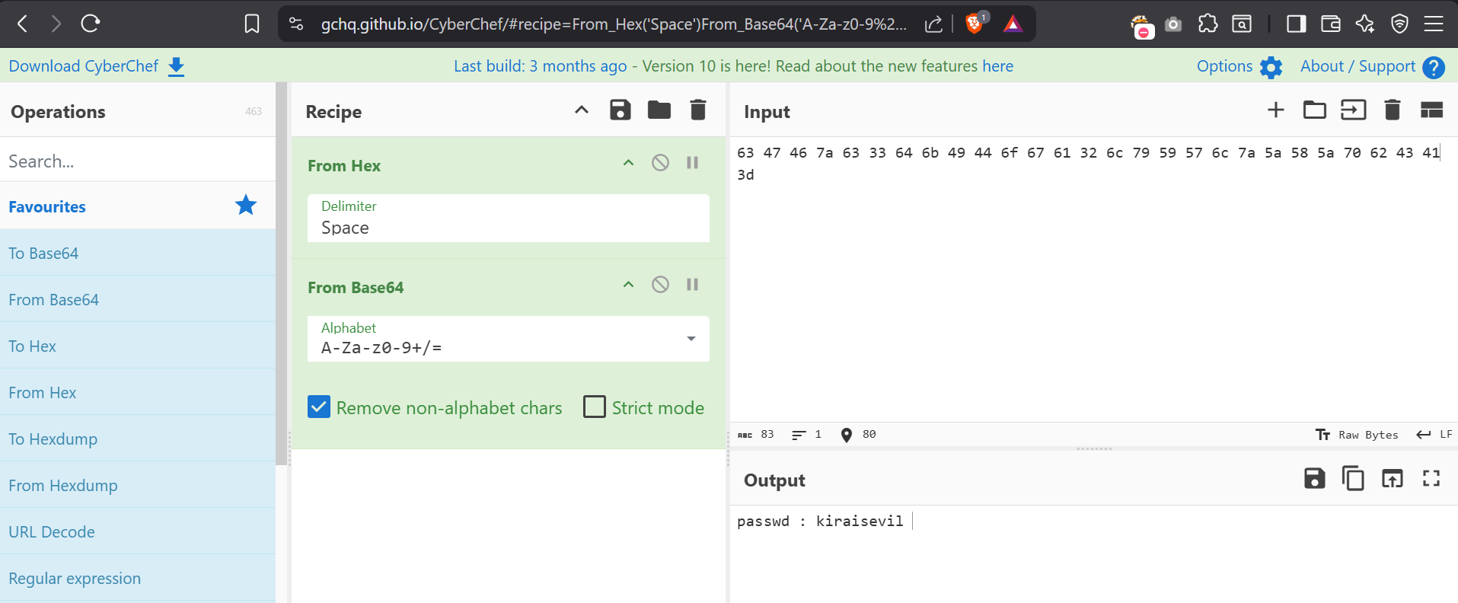  We got password here kiraisevil  STEP 9 – let’s try to switch to kira user  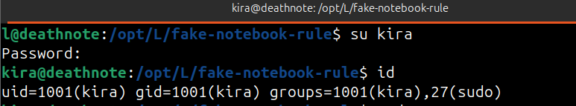  - Kira is member of Sudo group lets try to switch root user  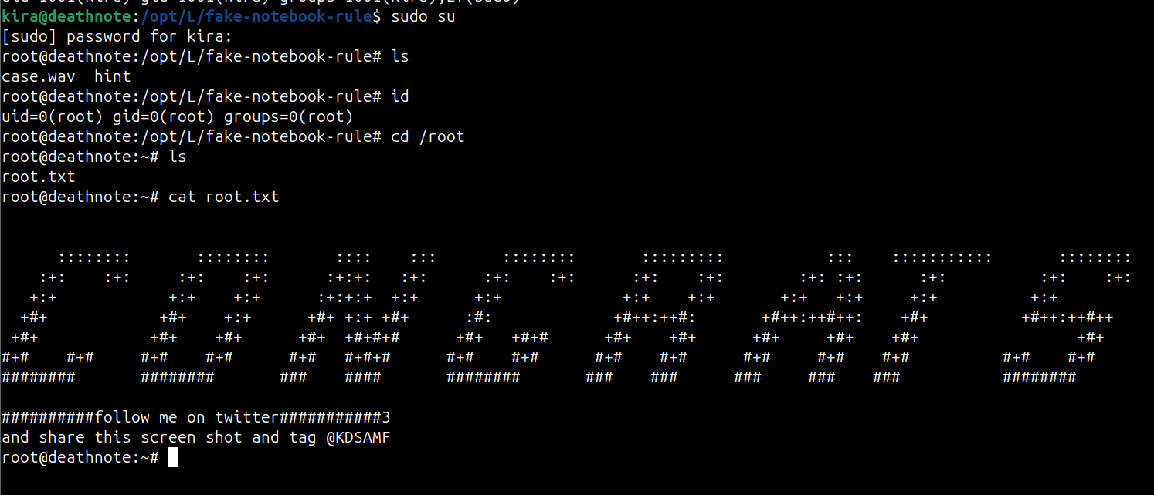  GOT ROOT !! MACHINE IS SOLVED ..
Impact | - attacker obtains remote code execution on the host.  - attacker recovers valid credentials and gains persistent access.  - attacker escalates to root and achieves full system compromise.
Remediations | - fix web input validation and secure file handling; remove unsafe execs.  - remove plaintext credentials and rotate secrets; store secrets in vaults.  - audit sudoers and SUID binaries; apply principle of least privilege and patch kernel if needed.
Reference | https://www.fortinet.com/resources/cyberglossary/brute-force-attack  https://vickieli.dev/system%20security/sudo-privesc/

